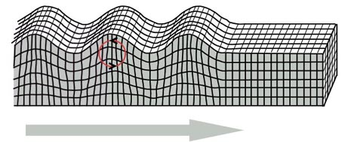
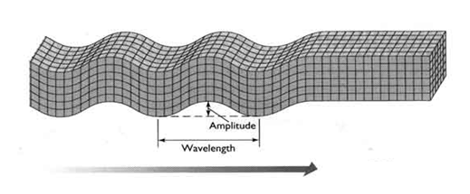

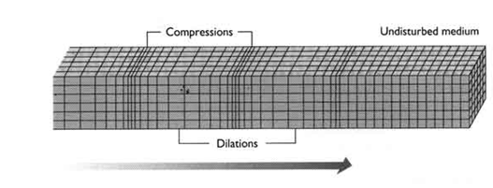

Summary of Wave Movement Speed
Slower than P Waves, Faster than Surface Waves

Vibrate from side to side or up and down
Compress and expand like an accordion
Location
Other Info
Travel through crust on Earth’s surface
Can only travel through Solids
P and S waves become this if they reach surface

The first waves to hit surface aka Primary
Also called secondary, sheet or side waves
Can travel through Solids & Liquids
Slowest of all wave types

Fastest of all wave types
Can make ground roll like waves or up and down
Wave Type | Picture of Wave Movement | Summary of Wave Movement | Speed | Location | Other Info
P - Wave
S- Wave
Surface Wave
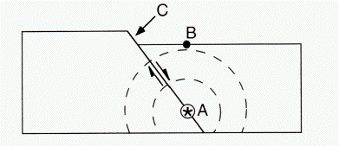
Use the diagram below to answer the following questions.
- What type of fault is shown? ________________________
- What does A represent? ___________________________
- What does B represent? ___________________________
- What does C represent? ____________________________
Wave Type | Picture of Wave Movement | Summary of Wave Movement | Speed | Location | Other Info
P - Wave | Compress and expand like an accordion | Fastest of all wave types |  | The first waves to hit surface aka Primary  Can travel through Solids & Liquids
S- Wave | Vibrate from side to side or up and down | Slower than P Waves, Faster than Surface Waves | Can only travel through Solids | Also called secondary, sheet or side waves | P and S waves become this if they reach surface
Surface Wave |  | Slowest of all wave types  Can make ground roll like waves or up and down |  | Travel through crust on Earth’s surface
Use the diagram below to answer the following questions.
- What type of fault is shown? REVERSE
- What does A represent? FOCUS
- What does B represent? EPICENTER
- What does C represent? FAULT LINE

