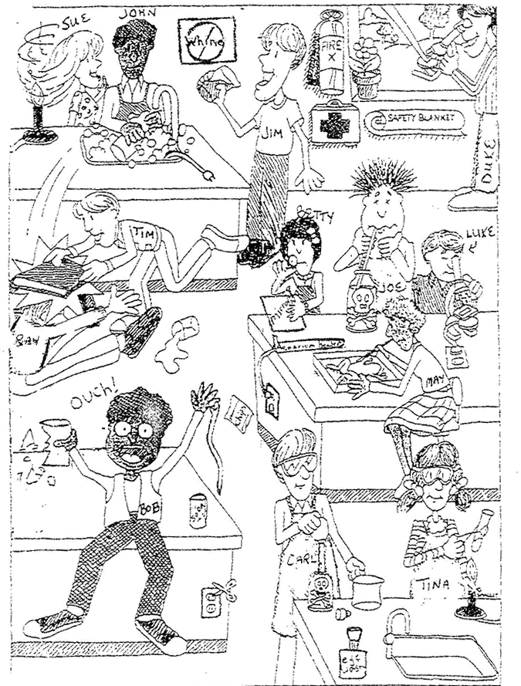
Lab Safety Cartoon Name ___________________ Period __ Date _________
4 pts. Total.
What’s Wrong With This Picture? PLENTY.
Directions:
- Look carefully at the picture below
- Answer the questions that follow. You may collaborate with other students to help you AFTER you have tried to find them on your own.
Questions (you can answer them on the back of this sheet or on a separate piece of paper):
1. List 3 unsafe activities shown in the illustration and explain why each is unsafe.
2. List 3 things that the students are doing CORRECTLY as shown in the illustration.
3. What should Bob do after the accident?
4. What should Sue have done to avoid an accident?
5. What are three things shown in the lab that should not be there?
6. Compare how Joe and Carl get liquid from a bottle. Who is doing it the correct way?
7. What is likely to happen to Ray and Tim when the teacher catches them?
8. List 3 items in the illustration that are there for the safety of the students in the lab.

